HTML ,Show Different Images Depending on Browser Width

<picture> element allows you to define different images for different browser window sizes.
https://www.w3schools.com/html/tryit.asp?filename=tryhtml_responsive_picture
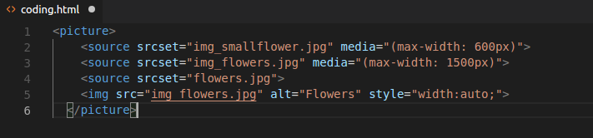

image sprites web app
An image sprite is a collection of images put into a single image.
A web page with many images can take a long time to load and generates multiple server requests.
Using image sprites will reduce the number of server requests and save bandwidth.
http://css.spritegen.com
css Grid fr

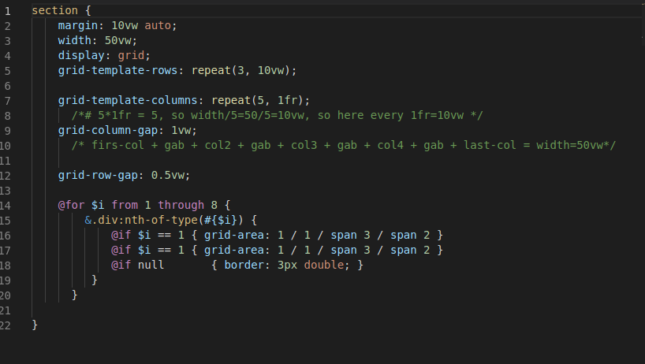


Git is a free and open source distributed version control system designed to handle everything from small to very large projects with speed and efficiency.
All the commands start by git
Advantages :
- it is free
- create snapshot
- snapshot to snapshot
- local storing or online server (it is called “repository مستودع”, push and pull)
- update the code and save the old too

1- create the repository folder and make it as Home directory.

2- make it as local git repository.
git init

note: the git commands will apply only under this home directory (Git repository)
3- to be sure if it is Master
git status

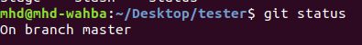

4-

5-

6-
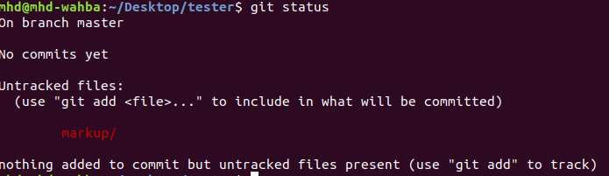
7-
git add –-all
or
git add FileName

git add . adds all modified and new (untracked = not saved) files in the current directory and all subdirectories to the staging area (a.k.a. the index) that which files need to make the Snapshot , thus preparing them to be included in the next git commit .
8-
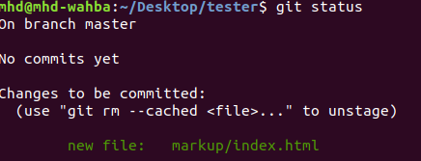
9- create git acount

git config --global user.email best.pid@gmail.com

10- create Snapshot
git commit -m 'initial commit from Mohammed'

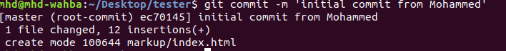
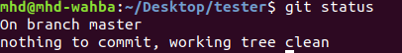
11- to show all commits
git log … more details
git log – -oneline -<number> …. short details.. <number> is number of last commit

12- to show what it is changed before to add
git diff
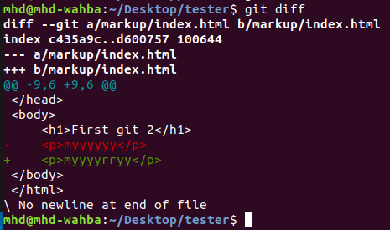
13- to backup from last snapshot
git revert HEAD … not on Master , not after push

14- to clone(download) file from github.com
git clone https://github.com/blindthief10/course.git

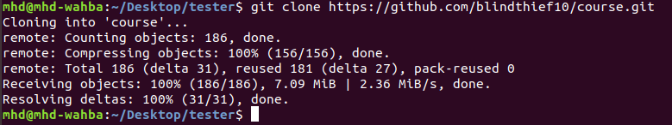
to delete the cloned(downloaded) file
rm -rf <file name> ….. m -rf course

- to backup to certain snapshot …. will delete the previous commits
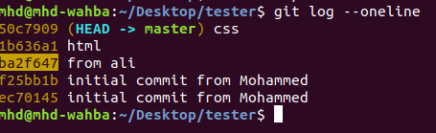
git reset –-hard <ID> …. hard will delete also the last stage area

git reset –-soft <ID> …. soft will not delete also the last stage area

Stage area : if done ‘git add - -all’ ,and not done ‘git commit -m ‘mhd’’

note: we never done this on master, but on only branches.

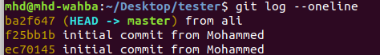
Note that it was deleted was before of the last ID reset.

- to backup to certain snapshot …. but without delete the previous commits

git checkout <ID>
git branch -b <new branch name>

- to make ssh connection setup between local git repository and remote git repository
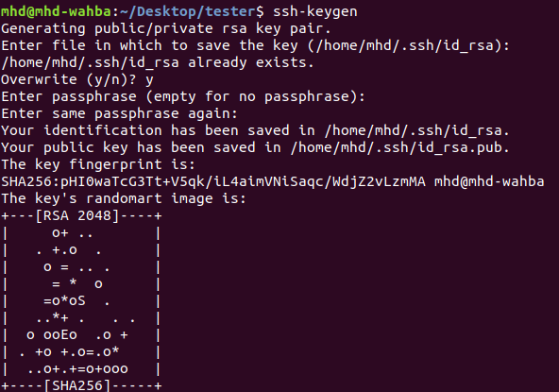
step 1 - ssh-keygen generation

1- ssh-keygen
three times : enter

2- cd ~/.ssh
ls -l

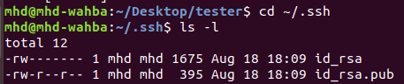
3- cat id_rsa.pub

and then the copy this public key

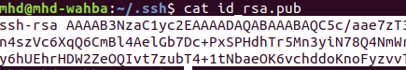

4- go to https://github.com/settings/keys
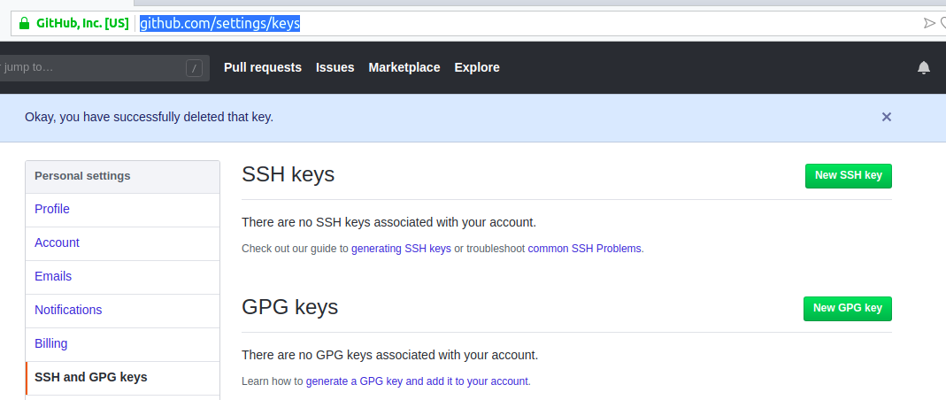

then copy the public key
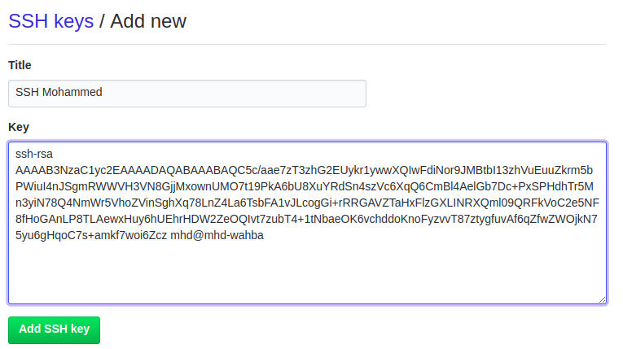
then enter your account’s password

5- change the home directory to git repository
cd $home
cd Desktop/tester

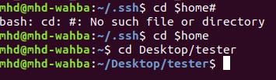
6- create .gitignore file to ignore file types ( no push to online git repository)

touch .gitignore
nano .gitignore
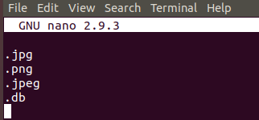
7- add and commit .gitignore file to local git repository

git add --all
git commit -m 'add .gitignore file'

8- copy the SSH the url of new online github repository

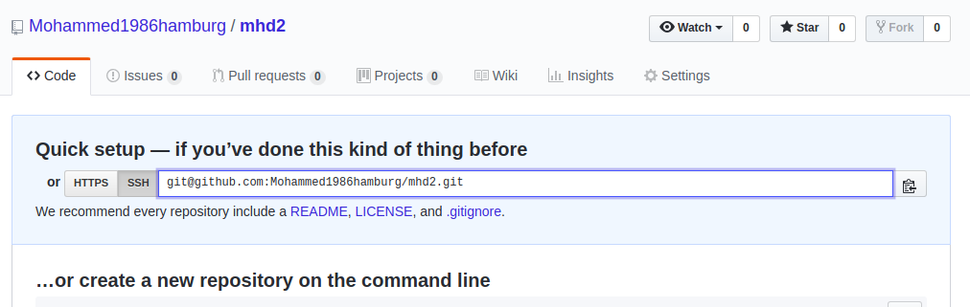

step 2- git remote add origin <url of new remote git repository>

- to show remote repository
git remote -v
- to remove remote repository
git remote remove <name>

step 3- git push --set-upstream origin master ….. to create file and connection between remote origin repository and local mgit aster branch

- to push from local master to remote repository
git push

the summary to push:

git add –-all
git commit -m 'my message'
git push

- to create branch
git branch … to see the branches ,* means which branch I am using
git branch <name> …. to add new branche
git checkout name ….. swich to the name branch
git push --set-upstream origin name ….. to create file and connection between remote origin repository and local name branch

the summary to push:

git add –-all
git commit -m 'my message'
git push …. or git push - –force ( never used in Master)

- to delete branch
git branch -d name

- to merge branch to master
- git checkout master
- git diff master name
-git merge name
-git push

- to Pull from online repository ( Fetch+Merge with local )
git pull

or pull from different remote branch name
git pull origin <remote branch name>

*git pull is shorthand for git fetch followed by git merge <branch>

- to go back one step (redo )
git reset HEAD …. ignore last change on repository
git checkout - - <file name.__> ……ignore last change on this file

- to Marge a current commit with last commit
git commit - -amend …. but it will generate new ID

- to create new branch and switch to it
git checkout -b <new branch>

- to merge all remote branches together , to create the final file project

step 1 on my branch -to decide which the right code-
………… wait for anther branch to push………
-git pull origin <my partner branch> ….. to download the remote files of <my partner branch> .. this local
-git checkout <my name branch>
-git merge <my partner branch>
… check the codes and accept which it…
-git add - -all
-git commit -m ‘message’
-git push

then every branch have to do the above

step 2 on my master- to merge to master
-git checkout master ….
-git merge <my name branch>
-git add - -all
-git commit -m ‘message’
-git push

- to see all the actions and commands
git reflog

- to undo the file if not done ‘git add - -all’ ,and not done ‘git commit -m ‘mhd’’
git checkout - - <file name>
- to undo the file if done ‘git add - -all’ ,and not done ‘git commit -m ‘mhd’’
git reset HEAD <file name>
git checkout - - <file name>

- rebase to merge but keeps the commits of your current branch on top
git rebase jake …... rebase is merges , but Rebase brings all commits from the specified branch but keeps the commits of your branch on top of them.

- to go back to the commit with hash eb49uf2 safely without deleting all the in-between commits
Git checkout <ID>

- cherry-pick To bring a specific commit from different branch. This commit will go on top of your commits.
git cherry-pick <ID>

- stash to Save temporarily untracked files without commit
git stash …. Save temporarily untracked files without commit
git stash pop ….. Bring the stashed files back to life

-to unstage a file that i have accidentally staged
git reset HEAD <file name>

ex:
git reset HEAD jake.html …... Unstage jake.html

--------------------------------------------------------------------------------------

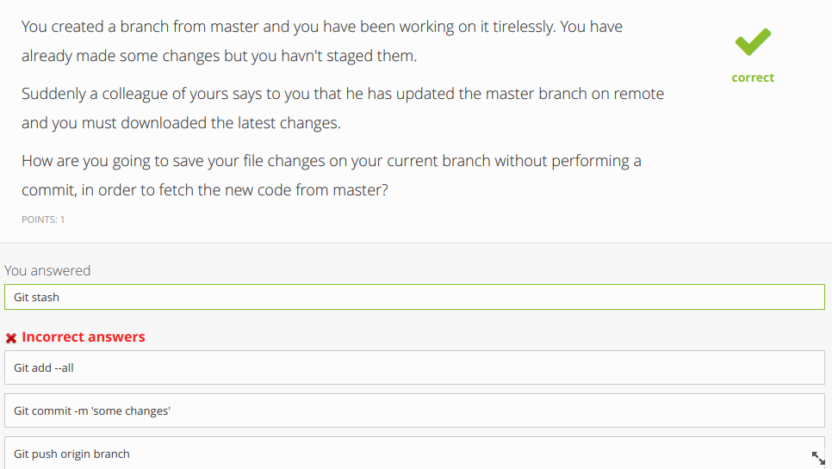
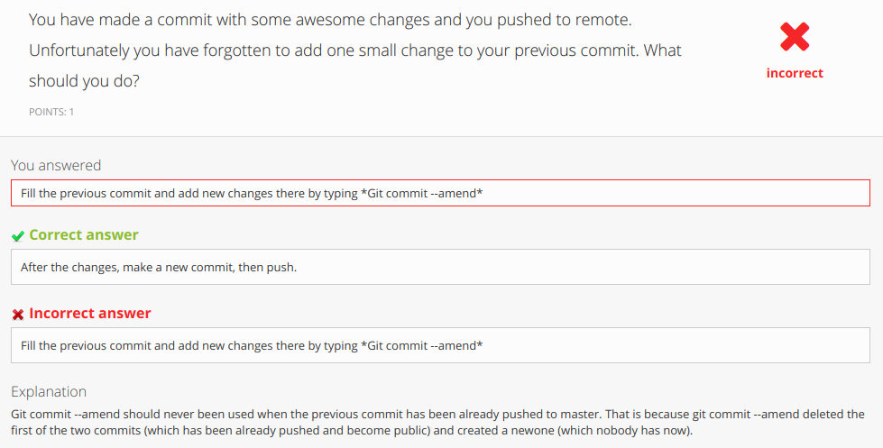

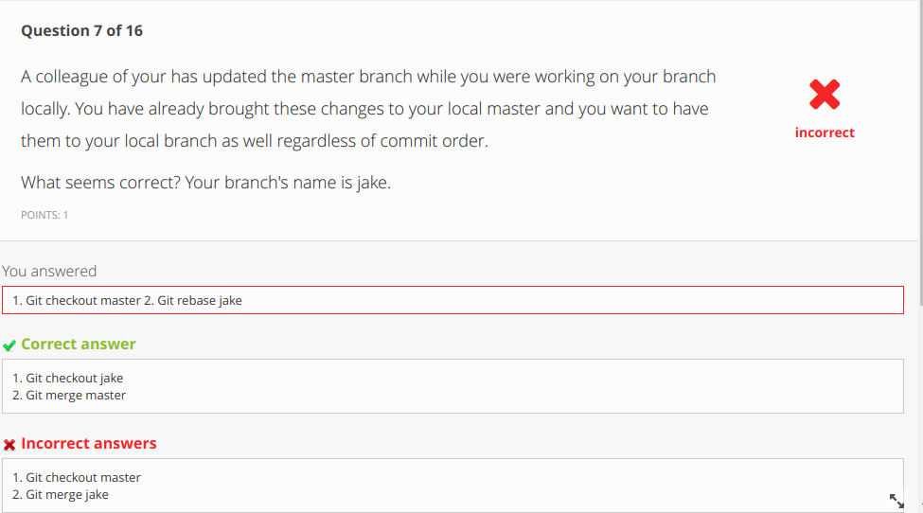
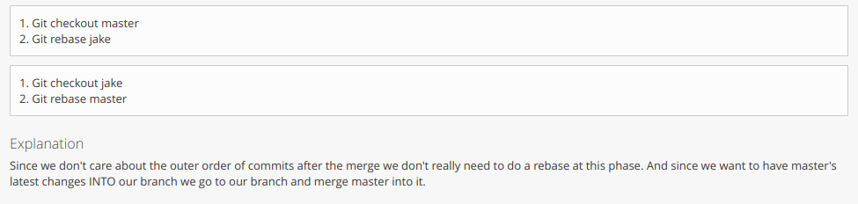
------------------------------------------------------------------------------------------------------------------------

JavaScript

css Example
Css Example

css Example
Css Example 6 7 11 13 14 15

css Example
Css Example

